Getting Started with Fuse
What Fuse is, signing in, and finding your way around
Fuse Manufacturing — user guide 01

What Fuse is for
Fuse is where you record what physically happens to stock. Material moved between warehouses, components issued to the factory floor, and goods manufactured — those are the jobs Fuse exists to capture.
Sage Intacct remains the accounting system. It holds the same stock figures Fuse does, and it holds the money. Every movement you record in Fuse is sent to Intacct as you submit it, which is why you never enter anything twice.
If you have used a stock system before, the important difference is this. Fuse is not a separate copy of Intacct that somebody reconciles at month end. It is the same stock, seen from the factory floor instead of from the accounts office.

What you will be doing in it
Four jobs, and no more than four. If what you are about to do is not one of these, it probably belongs in Intacct.

Tile | What it does
Works Orders | Record what you have manufactured against a production order. Components are consumed and finished goods are created.
Issue to WIP | Move components out of a store into a work-in-progress warehouse, ready for a production run.
Item Transfer | Move stock from one warehouse to another. Nothing is made, bought or used.
Stock Control | Look things up: stock levels, movement history, and what is still on order from suppliers.

Each has its own guide. Read the one for the job in front of you — you do not need to read them all before you start.

Signing in
- Open your browser and go to the Fuse address your administrator gave you.
- Enter your email address and your password.
- Click Continue.
You will land on Fuse Home. If you find yourself somewhere else, click Fuse Home in the list down the left-hand side.
If your password does not work, use Forgot password on the sign-in screen rather than trying repeatedly.

The Fuse Home screen
This is your starting point for every job. It is deliberately plain: a green banner showing who is signed in, which company you are working in and today's date, and beneath it the four tiles.
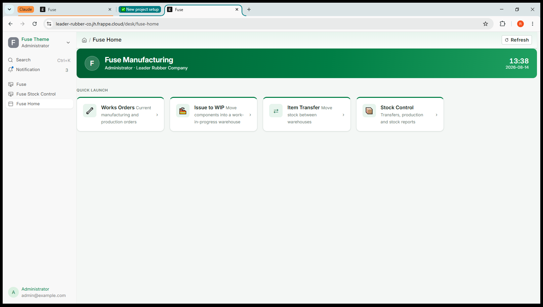
Screenshot 1 — Fuse Home, with the four tiles under QUICK LAUNCH
Click a tile to start. You do not need to understand the menus behind it — each guide tells you exactly which boxes to fill in and which to leave alone.

What you will see behind the tiles
Clicking a tile takes you into the wider system, and those screens look busier than Fuse Home. There will be fields, tabs and buttons the guides never mention.
That is normal and it is not a sign you are in the wrong place. The system can do a great deal that Leader Rubber does not use. Fill in what the guide names and ignore the rest.

Finding your way back
Two ways, from anywhere:
- Click Fuse Home in the list down the left-hand side.
- Use your browser's back button, which behaves normally throughout.
That same list also has Fuse Stock Control, which is where the Stock Control tile takes you — useful for looking something up without going via Home.
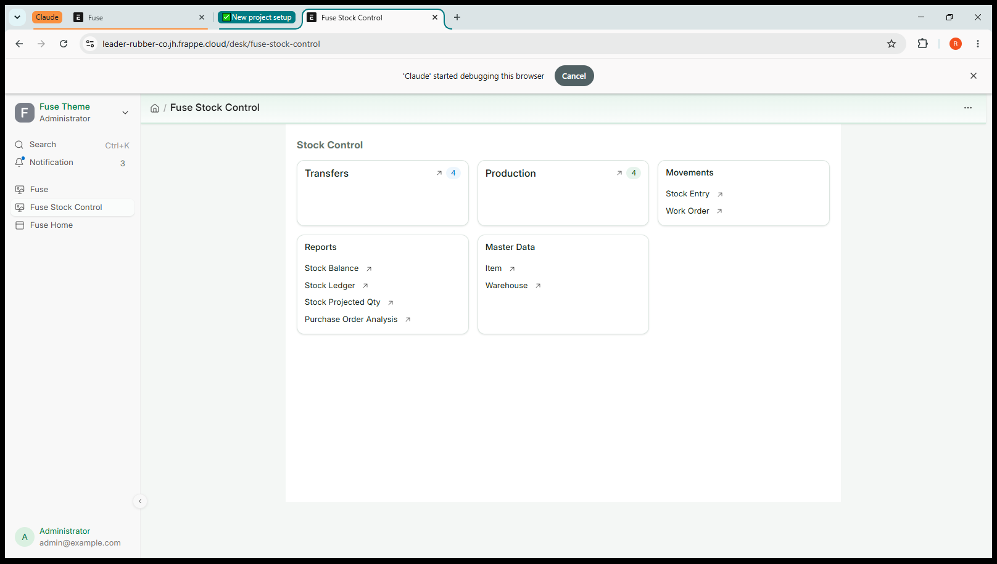
Screenshot 2 — The Stock Control screen, reached from the tile or from the list on the left

Two rules that apply to everything in Fuse

Saving is not submitting
Saving stores a draft. A draft changes no stock at all, in Fuse or in Sage Intacct, and you can edit it, leave it, or delete it freely. Nothing has happened yet.
Submitting is the moment it becomes real. Fuse sends the movement to Intacct, and only once Intacct has accepted it does Fuse record it here. Read your work between the two.

Cancel, never delete
If you get something wrong after submitting, open the document and choose Cancel. Fuse reverses the movement in Intacct first, then cancels it here, so both systems return to where they were.
Do not delete, and do not try to correct a mistake by entering a second, opposite movement. Deleting would remove the record here while Intacct still holds the movement, and an opposite entry leaves two wrong movements in the history instead of none.

Why the two systems cannot disagree
Fuse and Sage Intacct hold the same stock. Fuse always sends the movement to Intacct first and waits for it to be accepted. If Intacct refuses, nothing is saved in either system and the reason appears on screen. That is why you never enter anything twice, and why nobody has to reconcile the two afterwards.

Jobs that belong in Intacct
Fuse will stop you doing these, with a message explaining why. Nothing is saved and nothing is broken — the job simply belongs in the other system.

If you try to | What happens
Receive goods from a supplier | Refused. Goods receipting is done in Intacct. Fuse shows what is on order so you can plan, but the receipt is recorded there.
Adjust stock up or down | Refused. On-hand corrections are made through a Cycle Count in Intacct.
Change an item, warehouse or supplier | Read-only here. These come from Intacct, and a change made in Fuse would be overwritten at the next sync.

If a message appears
Fuse would rather stop you than record something wrong. A message on a red or orange background means nothing has been saved.
- Read it. It names the problem and usually the row it is on.
- Fix that one thing.
- Try again.
If the message mentions Intacct and you cannot see what to correct, copy the wording and send it to your administrator. Do not work around it by entering the movement a different way — the block is there for a reason.

Your first hour
A sensible order for learning, on the training system, before you touch anything live:
- Sign in and find your way to Fuse Home and back a few times.
- Open Stock Control and look up an item you know in Stock Balance.
- Do one Item Transfer of a small quantity, then check it in Stock Balance.
- Cancel that transfer, and check the figures return to where they started.
- Only then move on to Issue to WIP and Works Orders.
If step four behaves the way you expect, you have understood the most important thing in the system: everything can be undone properly, and the numbers always tell you the truth.

Where this goes
Fuse and Sage Intacct hold the same stock. Anything you submit here is sent to Intacct immediately, and Fuse only records it once Intacct has accepted it. If Intacct refuses, nothing is saved in either system and you will see the reason on screen.

